

transport layer

Introduction to Networking and Security



November 17, 2019

Jamie lu

W0441213

Table of Contents

Introduction: 2

Question 3 3

Activity 9.1.2.10 3

Screenshot of 1 of Activity 9.1.2.10 3

Screenshot of 2 of Activity 9.1.2.10 3

Question 4 4

Activity 9.2.1.7 4

Screenshot of 1 of Activity 9.2.1.7 4

Screenshot of 2 of Activity 9.2.1.7 4

Question 5 5

Activity 9.2.4.4 5

Screenshot of 1 of Activity 9.2.4.4 5

Question 7 6

Activity 9.3.1.2 6

Screenshot of the PDU that originated from the HTTP Client 6

Screenshot of the PDU that originated from the FTP Client 8

Screenshot of the PDU that originated from the E-mail Client 10

Screenshot of the Active Connections 12

References 13

Appendix 14

Appendix A – Cisco Commands Tool Kit 14

# Introduction:

This assignment contains activities that used learnings from Cisco’s CCNA R&S: Introduction to Networking: Chapters 9[1]. This assignment also contains the continued information learned and skills acquired with regards to the topics that were covered in previous chapters and in Chapter 9, The Transport Layer, UDP and TCP.

# Question 3

## Activity 9.1.2.10

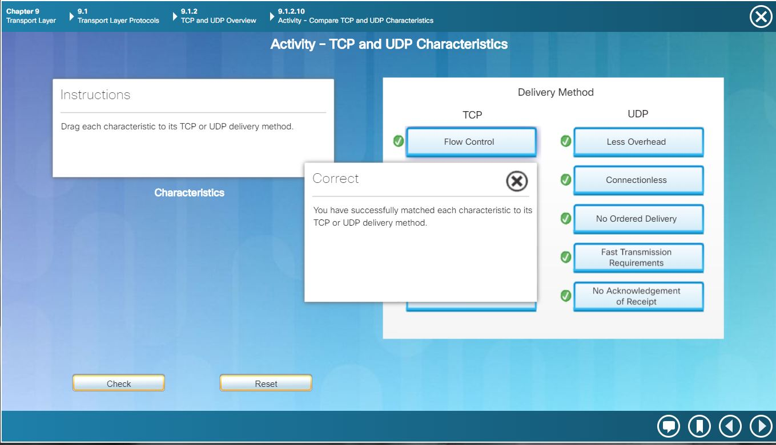

### Screenshot of 1 of Activity 9.1.2.10

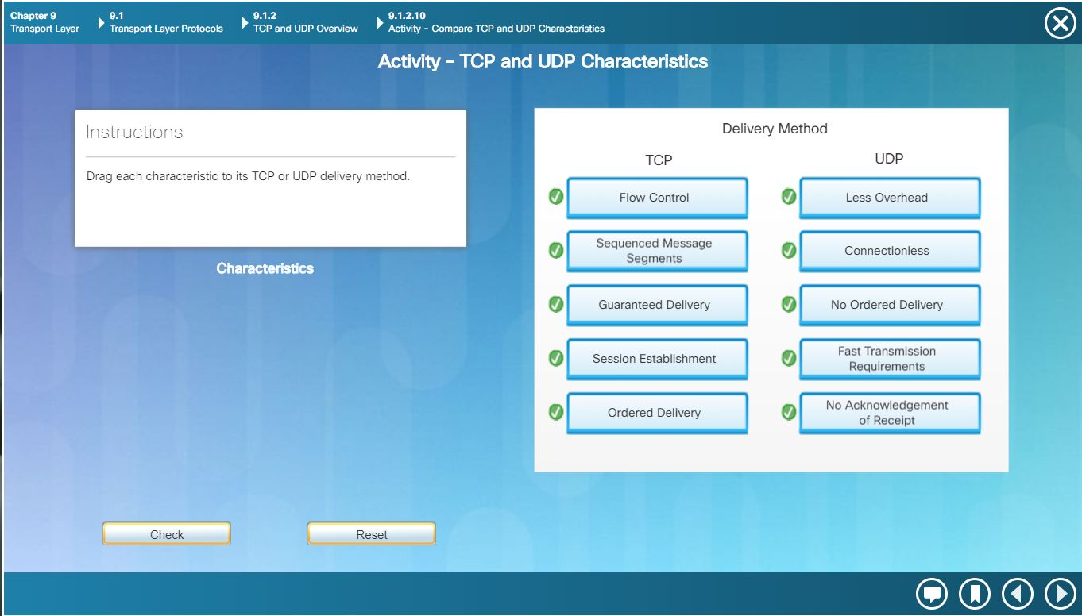

### Screenshot of 2 of Activity 9.1.2.10

# Question 4

## Activity 9.2.1.7

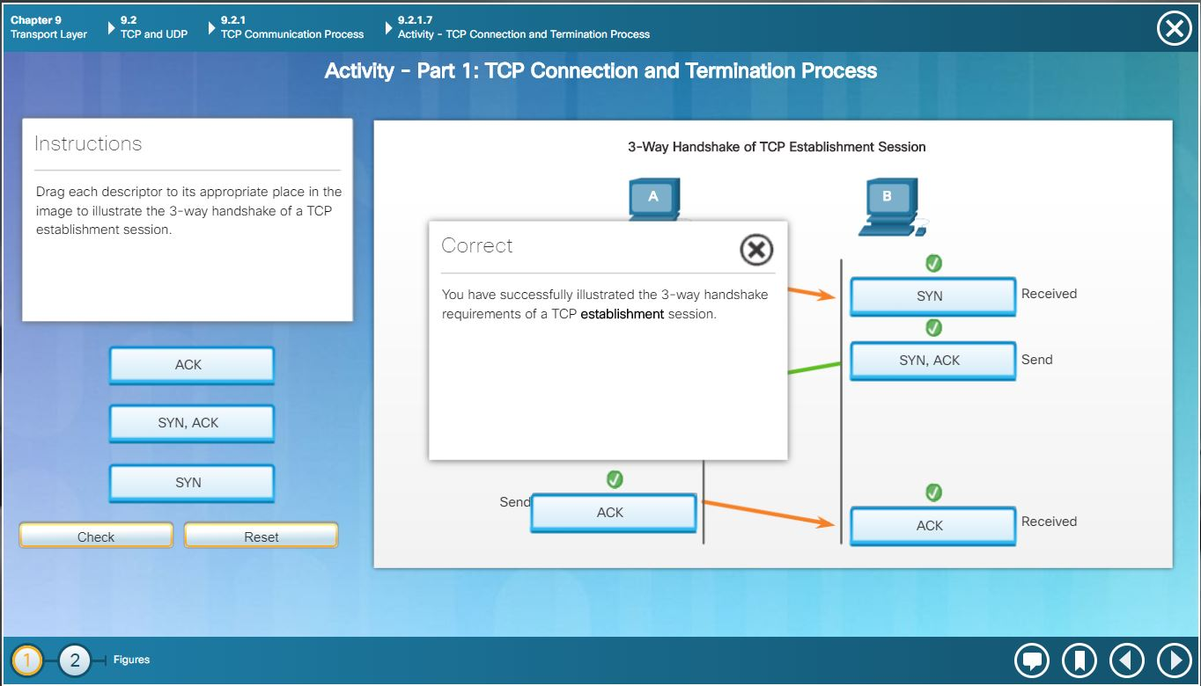

### Screenshot of 1 of Activity 9.2.1.7

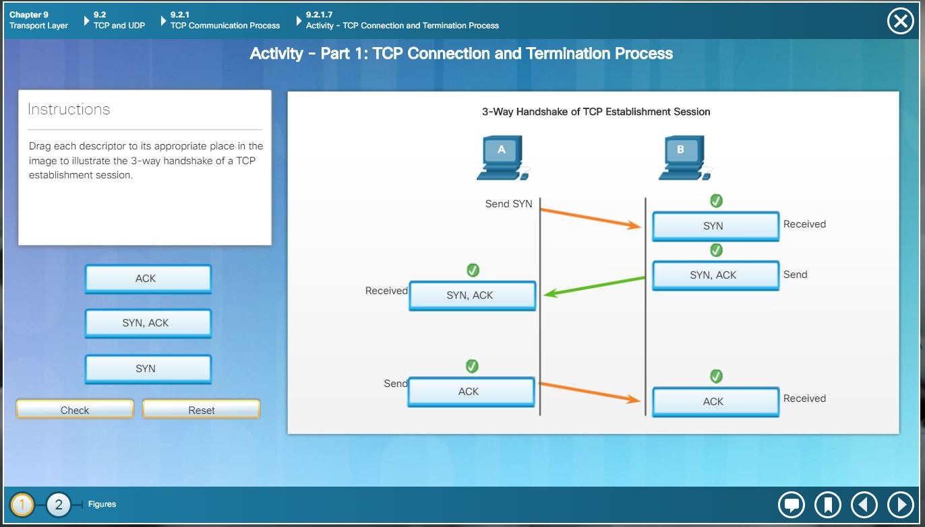

### Screenshot of 2 of Activity 9.2.1.7

# Question 5

## Activity 9.2.4.4

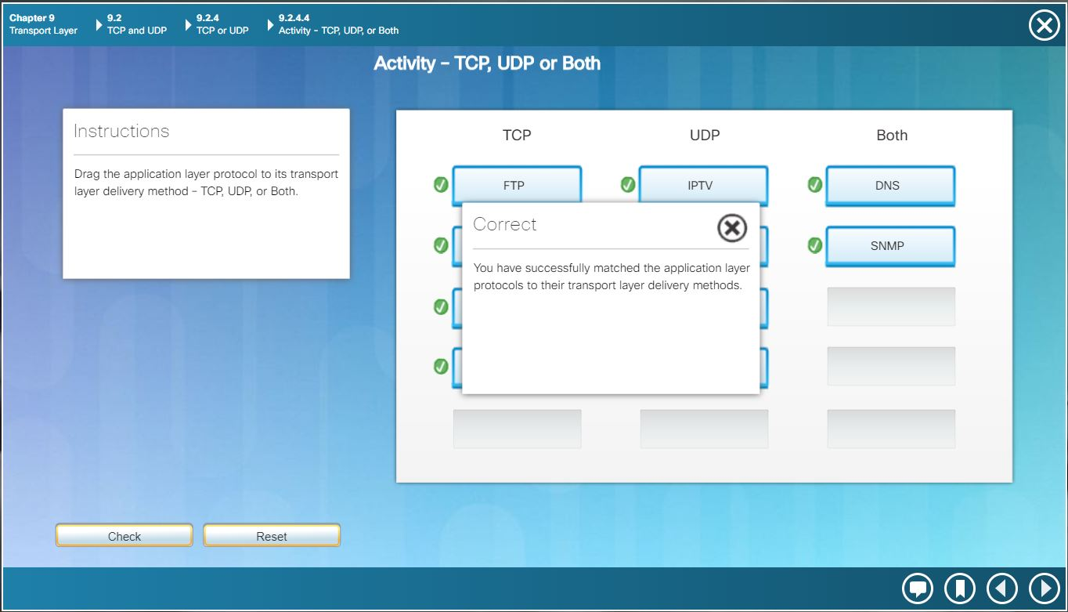

### Screenshot of 1 of Activity 9.2.4.4

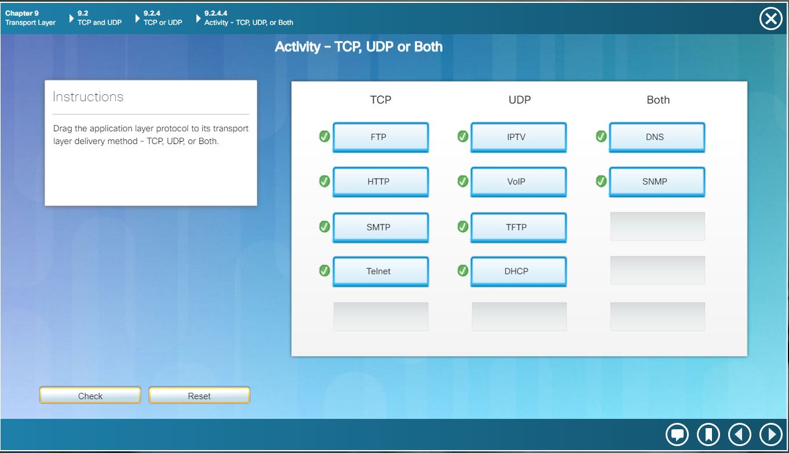Screenshot of 1 of Activity 9.2.4.4

# Question 7[2]

## Activity 9.3.1.2

Part 2: Step 1:

b. Click Capture/Forward again. Some of the PDUs disappear. What do you think happened to them?

- The PDU’s are being stored in the switch.

c. Click Capture/Forward six times. All clients should have received a reply. Note that only one PDU can cross a wire in each direction at any given time. What is this called?

- This is called Multiplexing.

d. A variety of PDUs appears in the event list in the upper right pane of the simulation window. Why are they so many different colors?

- The different colors represent the different protocols used.

Step 2:

b. Click Capture/Forward. Hold your mouse above each PDU until you find one that originates from HTTP Client. Click the PDU envelope to open it.

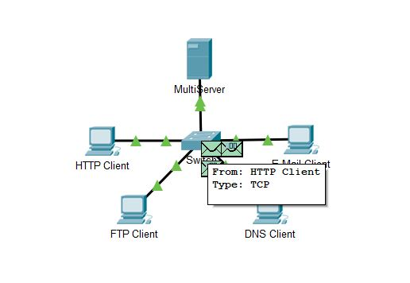

### Screenshot of the PDU that originated from the HTTP Client

c. Click the Inbound PDU Details tab and scroll down to the last section. What is the section labeled?

- The section is labeled as TCP.

Are these communications considered to be reliable?

- Yes, TCP communications are reliable because it numbers and tracks data, acknowledges it and retransmits any data that isn’t acknowledged after a certain period of time has passed.

d. Record the SRC PORT, DEST PORT, SEQUENCE NUM, and ACK NUM values. What is written in the field to the left of the WINDOW field?

- SRC PORT: 1025, DEST PORT: 80, SEQ NUM: 0, ACKNOWLEDGEMENT NUM: 0

- FLAGS: 0b000010 (SYN), is located to the left of the WINDOW field followed by RESERVED: 0b000000 then OFFSET: 0x0, respectively.

f. Click the PDU envelope and select Inbound PDU Details. How are the port and sequence numbers different than before?

- SRC PORT: 80, DEST PORT: 1025, SEQ NUM: 0, ACKNOWLEDGEMENT NUM: 1

- The source and destination port are now reversed. There is also an acknowledgement shown as 1. The SYN was changed to SYN+ACK.

h. What information is now listed in the TCP section? How are the port and sequence numbers different from the previous two PDUs?

- SRC PORT: 1025, DEST PORT: 80, SEQ NUM: 1, ACKNOWLEDGEMENT NUM: 1, PSH+ACK

- The SRC and DEST port are the same with the first PDU and reversed from the second PDU. The sequence and acknowledgement numbers are also shown as 1 now.

Step 3:

b. Click Capture/Forward. Hold your cursor above each PDU until you find one that originates from FTP Client. Click that PDU envelope to open it.

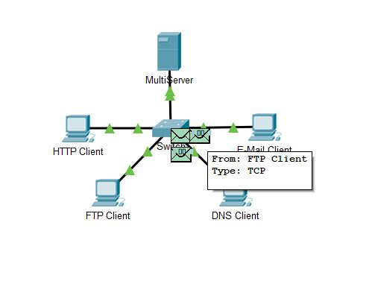

### Screenshot of the PDU that originated from the FTP Client

c. Click the Inbound PDU Details tab and scroll down to the last section. What is the section labeled?

- The section is labeled as TCP.

Are these communications considered to be reliable?

- Yes, TCP communications are reliable because it numbers and tracks data, acknowledges it and retransmits any data that isn’t acknowledged after a certain period of time has passed.

d. Record the SRC PORT, DEST PORT, SEQUENCE NUM, and ACK NUM values. What is written in the field to the left of the WINDOW field?

- SRC PORT: 1025, DEST PORT: 21, SEQ NUM: 0, ACKNOWLEDGEMENT NUM: 0

- FLAGS: 0b000010 (SYN), is located to the left of the WINDOW field followed by RESERVED: 0b000000 then OFFSET: 0x0, respectively.

f. Click the PDU envelope and select Inbound PDU Details. How are the port and sequence numbers different than before?

- SRC PORT: 21, DEST PORT: 1025, SEQ NUM: 0, ACKNOWLEDGEMENT NUM: 1, SYN+ACK

- The source and destination port are now reversed. There is also an acknowledgement shown as 1.

g. Click the Outbound PDU Details tab. How are the port and sequence numbers different from the previous two results?

- SRC PORT: 1025, DEST PORT: 21, SEQ NUM: 1, ACKNOWLEDGEMENT NUM: 1, ACK

- The source and destination port are now reversed, both the sequence number and acknowledgement number are showing 1.

i. Open the PDU and select Inbound PDU Details. Scroll down past the TCP section. What is the message from the server?

- The message says, “Welcome to PT Ftp server”

Step 4:

c. Click the Inbound PDU Details tab and scroll down to the last section. What is the section labeled?

- This section is labeled as UDP

Are these communications considered to be reliable?

- No, these communications are not considered reliable because there is no error-checking in UDP, there is no acknowledgement from the destination that the delivery has been received.

d. Record the SRC PORT and DEST PORT values. Why is there no sequence and acknowledgement number?

- SRC PORT: 1025, DEST PORT: 53.

- There is no sequence and acknowledgement number because UDP does not have error-checking and does not need an acknowledgement from the destination. It doesn’t need to establish a reliable connection, unlike the TCP.

f. Click the PDU envelope and select Inbound PDU Details. How are the port and sequence numbers different than before?

- SRC PORT: 53, DEST PORT: 1025.

- The source and destination ports have reversed and there is still no sequence and acknowledgment numbers.

g. What is the last section of the PDU called?

- The last section is called DNS Answer.

Step 5:

b. Click Capture/Forward. Hold your cursor above each PDU until you find one that originates from E-mail Client. Click that PDU envelope to open it.

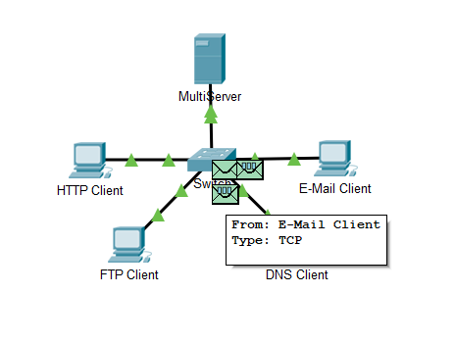

### Screenshot of the PDU that originated from the E-mail Client

c. Click the Inbound PDU Details tab and scroll down to the last section. What transport layer protocol does email traffic use?

- The transport layer protocol it uses is TCP.

Are these communications considered to be reliable?

- Yes, TCP communications are reliable because it numbers and tracks data, acknowledges it and retransmits any data that isn’t acknowledged after a certain period of time has passed.

d. Record the SRC PORT, DEST PORT, SEQUENCE NUM, and ACK NUM values. What is written in the field to the left of the WINDOW field?

- SRC PORT: 1025, DEST PORT: 25, SEQ NUM: 0, ACKNOWLEDGEMENT NUM: 0

- FLAGS: 0b000010 (SYN), is located to the left of the WINDOW field followed by RESERVED: 0b000000 then OFFSET: 0x0, respectively.

f. Click the PDU envelope and select Inbound PDU Details. How are the port and sequence numbers different than before?

- SRC PORT: 25, DEST PORT: 1025, SEQ NUM: 0, ACKNOWLEDGEMENT NUM: 1, SYN+ACK

- The source and destination port are now reversed. There is also an acknowledgement shown as 1.

g. Click the Outbound PDU Details tab. How are the port and sequence numbers different from the previous two results?

- SRC PORT: 1025, DEST PORT: 25, SEQ NUM: 1, ACKNOWLEDGEMENT NUM: 1, ACK

- The source and destination port are now reversed. The sequence and acknowledgement numbers now show 1.

i. How are the port and sequence numbers different from the previous two PDUs?

- SRC PORT: 1025, DEST PORT: 25, SEQ NUM: 1, ACKNOWLEDGEMENT NUM: 1, PSH+ACK

- The source and destination port are now reversed. The sequence and acknowledgement numbers now show 1.

j. What email protocol is associated with TCP port 25? What protocol is associated with TCP port 110?

- The email protocol associated with TCP port 25 is SMTP and TCP port 110 is POP3.

Step 6:

b. Enter the netstat command. What protocols are listed in the left column?

- The protocol listed is TCP.

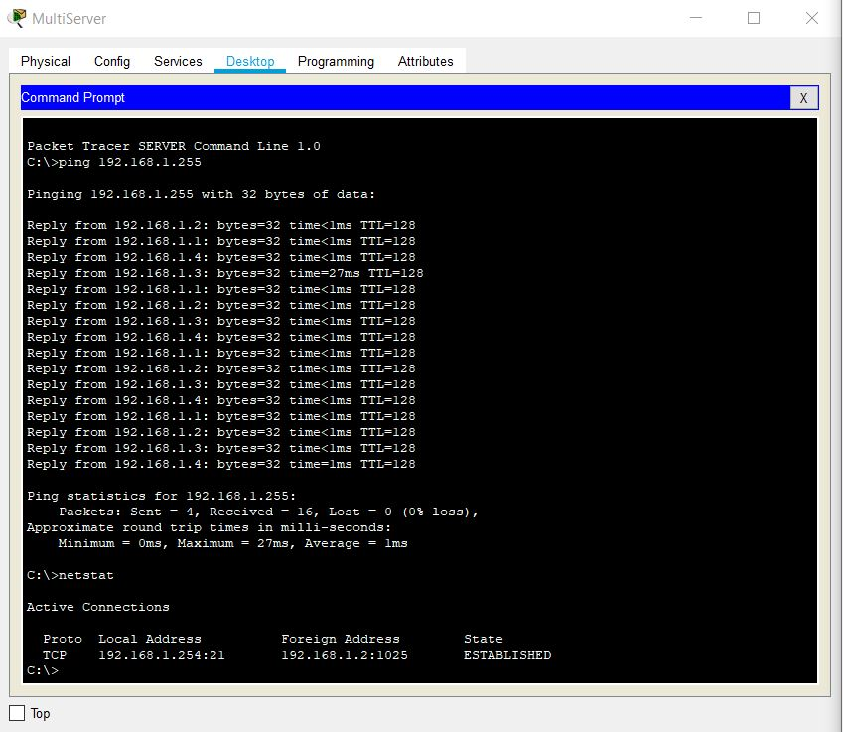

### Screenshot of the Active Connections

What port numbers are being used by the server?

- port 21 is being used by the server

c. What states are the sessions in?

- The session is in the ESTABLISHED state.

d. Repeat the netstat command several times until you see only one session still ESTABLISHED. For which service is this connection still open?

- It is for the FTP service.

Why doesn’t this session close like the other three? (Hint: Check the minimized clients)

* This is because the server is still waiting for a password input from the client.

# References

Cisco. (n.d.). *Chapter: Configuring Static Routing*. Retrieved November 15, 2019, from Cisco: https://www.cisco.com/c/en/us/td/docs/switches/datacenter/nexus3000/sw/unicast/503_u1_2/nexus3000_unicast_config_gd_503_u1_2/l3_route.html

Cisco Networking Academy. (n.d.). *Introduction to Networks, Chapter 9: Transport Layer*. Retrieved November 16, 2019, from Cisco Networking Academy: https://static-course-assets.s3.amazonaws.com/ITN6/en/index.html#2

Cisco Systems, Inc. (2010, April). *Cisco IOS Configuration Fundamentals*. Retrieved from Cisco: https://www.cisco.com/c/en/us/td/docs/ios/fundamentals/command/reference/cf_book.pdf

UNC Office of Arts and Sciences Information Services. (n.d.). *TCP Flag Key*. Retrieved November 15, 2019, from Packet-Scale Congestion Control: http://rapid.web.unc.edu/resources/tcp-flag-key/

Wikipedia. (n.d.). *Tranmission Control Protocol*. Retrieved November 15, 2019, from Wikipedia: https://en.wikipedia.org/wiki/Transmission_Control_Protocol

# 

# Appendix

## Appendix A – Cisco Commands Tool Kit[3]

**?** – this command will show the list of all the commands available for the specific mode you are currently in.

**(characters) ?** – this command is known as context-sensitive help. it will show the available commands in the current mode with the specific first characters you have entered. (example: **te?** in the user exec mode will show **te**lnet and **te**rminal, both starting with **te**.)

**banner motd “ ”** – this command will configure the message-of-the-day banner that will display when a user logs in to the switch.

**clock rate (rate)** – this command is used in DCE in serial link. This command configures the clock speed for the ink

**clock set (time and date)** – this command will allow you to set the time and date. (example: **clock set 15:00:00 july 11 2019)**

**copy startup-config flash –** this command will save the startup configuration to the flash memory. The flash memory is good to use as a back up.

**copy running-config startup-config** – this command will save the running configuration to the startup configuration.

**config terminal** – this command will open the global configuration mode.

**description Link to (server name)** – to describe the interface of the specified server.

**enable** – this command will open the privileged exec mode and will give additional commands.

**enable password** – this command followed by a password will set that same password for the privileged exec mode.

**enable secret** – this command followed by a password will set an ***encrypted*** password for the privileged exec mode.

**exit** – this command will exit the current mode.

**Flash –** this command will boot the router from Flash memory

**ip default-gateway –** this command will set the default gateway

**hostname** – this command followed by the name you want the hostname to be will change the hostname to what you want it to be.

**interface** – followed by the interface you want to configure will open that specific interface’s configuration mode.

EXAMPLES:

**interface fa0/0** - enter interface configuration mode for the FastEthernet interface

**interface s0/0/0** – enter interface configuration mode for the serial interface

**interface vlan <1-4094>**– you can use this command to configure an svi on a switch.

**ip address ­**– this command followed by the ip address and subnet mask you want will set the ip address and subnet mask to the entered values.

**ip route {ip-prefix | ip-addr ip-mask} {[next-hop | nh-prefix] | [interface next-hop | nh-prefix]} [tag tag-value [pref]][4] –** this command configures a static route and the interface for the static route.

EXAMPLE:

switch(config)# ip route 192.0.2.0/8 ethernet 1/2 192.0.2.4

switch(config)# ip route 192.0.2.0/8 192.0.2.10

**ipv6 unicast-routing –** in global configuration mode, this command will enable the router to forward IPv6 packets

**ipv6 address <ipv6 address> -** this command will manually assign a specific ipv6 address to an interface. Used in interface configuration mode. Insert no before ipv6 address to remove the address from an interface.

**ipv6 address <link local address> link-local-** this command manually assigns a specific link-local address to an interface and enables IPv6 processing on an interface. Used in interface configuration mode. Insert no before ipv6 address to remove the address from an interface.

**line** – this command will configure a terminal line.

**line console 0** – this command will open the line console configuration mode.

**line vty 0 15** – this command will open the virtual terminal configuration mode.

**login** – this command will enable password checking

**no shutdown** – this command enables an interface.

**password** – this command will set a password.

**ping** – this command will send a request to the destination and wait for the response. this is good for checking network connectivity.

**service password-encryption** – this command in the global config mode will encrypt all unencrypted passwords in the configuration file.

**show interface** – this command will display the status of the interfaces.

**show ip interface** – this command will display the configuration and status of the ip protocol.

**show ip interface brief** – this command gives a summary of the status and IP addresses of the interfaces

**show ip static-route[5] –** this command will display information about the static routes

**Show flash –** this command will show the files on the flash memory.

**show running-config –** this command will show the running configuration

**show startup-config** – this command will show all the startup configuration file.

**show clock** – this command will show the time and date.

***show?*** – this command would show all the show commands in the specific mode you are currently in.

1. (Cisco Networking Academy, n.d.)
2. References used: (UNC Office of Arts and Sciences Information Services, n.d.) and (Wikipedia, n.d.)
3. References and sources from (Cisco Systems, Inc., 2010)
4. Referenced from: (Cisco, n.d.)
5. Referenced from: (Cisco, n.d.)